Task 1
Kernel Architecture Diagram - Draw a detailed diagram of the Linux kernel architecture. Label and write a short description (2-3 sentences) for each major component like Scheduler, File System, Network Stack, etc.
Flow Diagram –
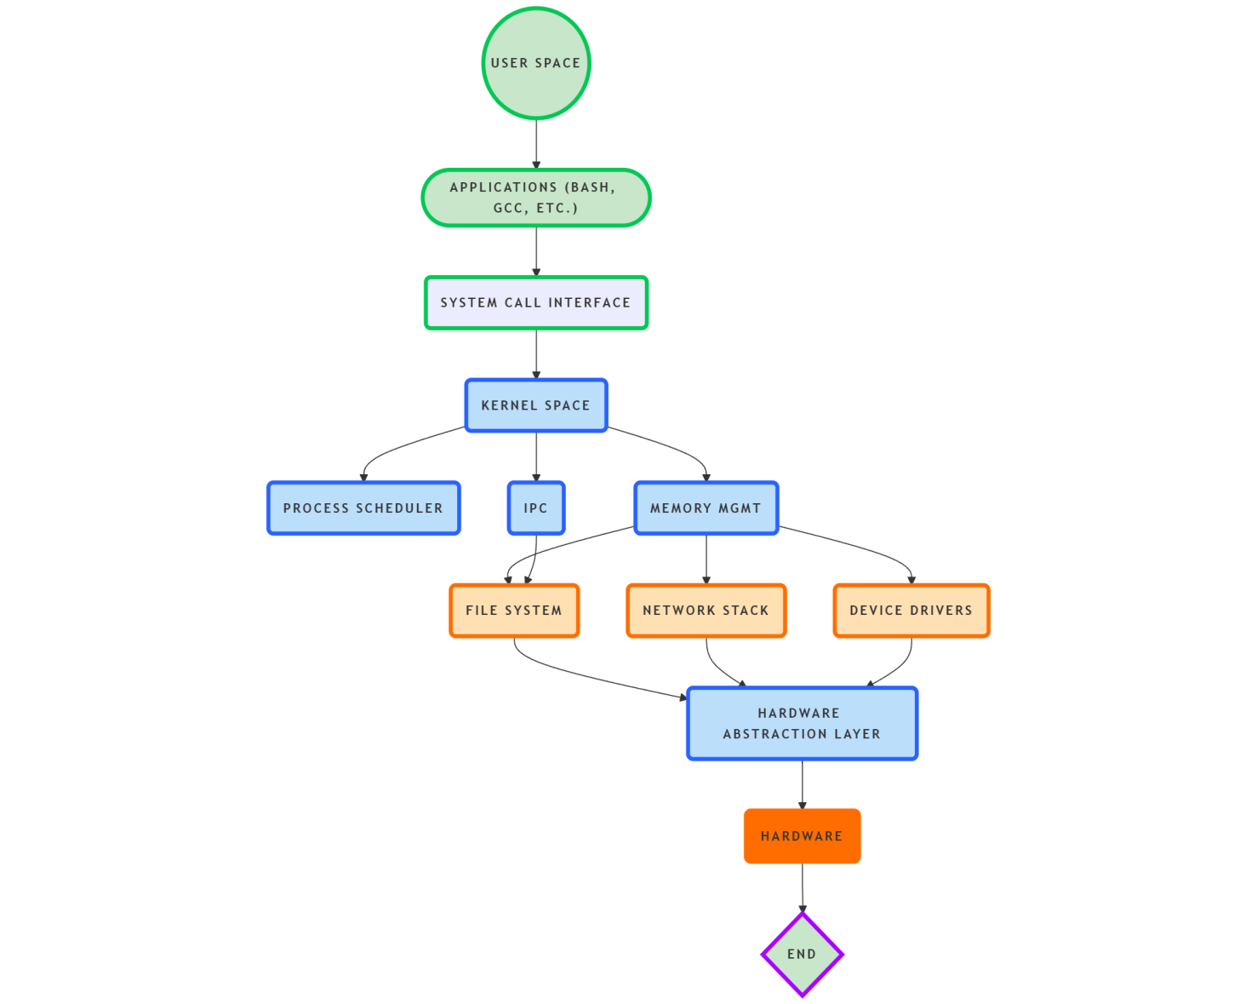

Conceptual diagram of the Linux kernel architecture
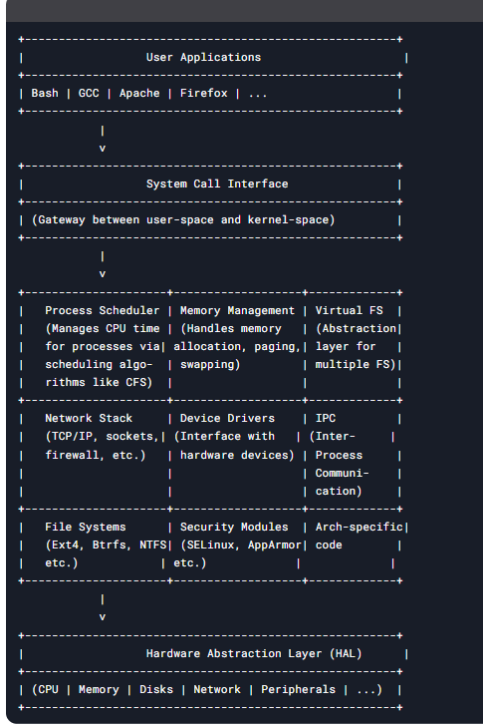

Key Components Explained:
- System Call Interface
The gateway between user applications and kernel services, providing controlled access to hardware/resources via ~400 syscalls.
- Process Scheduler
Manages CPU time allocation using algorithms like CFS (Completely Fair Scheduler), ensuring multitasking and process prioritization.
- Memory Management
Handles virtual memory, paging, swapping, and memory allocation via buddy system and slab allocator.
- Virtual File System (VFS)
Abstraction layer that unifies access to different filesystems (Ext4, NTFS, etc.) through common interfaces.
- Network Stack
Implements TCP/IP protocols, sockets, firewalls (netfilter), and network device drivers for communication.
- Device Drivers
Kernel modules that interface with hardware devices (storage, USB, GPU, etc.) through standardized APIs.
- IPC (Inter-Process Communication)
Mechanisms like pipes, shared memory, and message queues for process coordination.
- Security Modules
Framework for mandatory access control (e.g., SELinux) and capability-based security.
- Arch-Specific Code
Low-level hardware-dependent code for different CPU architectures (x86, ARM, etc.).

